**Recommendation System Documentation**

**Introduction**

A recommendation system is a machine learning-based application that suggests relevant items to users based on their preferences and past interactions. This system employs techniques like collaborative filtering and content-based filtering to recommend movies, books, or products, enhancing user experience and engagement.

**Module Description**

1. **Data Collection**: Gathers user preferences, item details, and historical interactions.
2. **Data Preprocessing**: Cleans and structures data for analysis.
3. **Content-Based Filtering**: Suggests items based on item attributes and user preferences.
4. **Collaborative Filtering**: Recommends items based on the behavior of similar users.
5. **Hybrid Recommendation**: Combines both approaches for improved accuracy.
6. **User Interface**: Displays recommendations to users via a command-line or web-based application.

**Work Flow Diagram**

+----------------+ +---------------+ +-------------------+

| User Input | ---> | Data Storage | ---> | Recommendation Engine |

+----------------+ +---------------+ +-------------------+

|

+--------------------------------+

| Recommendation Output |

+--------------------------------+

**Process of Work Flow**

1. **User Interaction**: The user provides input (e.g., ratings, preferences, search history).
2. **Data Processing**: The system processes and structures the input data.
3. **Recommendation Engine**:
   * **Content-Based Filtering**: Compares item features with user preferences.
   * **Collaborative Filtering**: Identifies similar users and suggests items based on their choices.
4. **Output Generation**: The system generates and displays recommendations.
5. **Feedback Loop**: User interactions are continuously recorded to refine recommendations.

**Future Enhancements**

* **Deep Learning Integration**: Use neural networks for better predictions.
* **Real-time Recommendations**: Implement dynamic recommendations based on live user behavior.
* **Multi-Domain Recommendations**: Expand beyond movies, books, and products to include music, courses, etc.
* **Personalized Filters**: Allow users to customize recommendation criteria.

**Tech Stack**

* **Programming Language**: Python
* **Libraries**: Pandas, NumPy, Scikit-learn, Surprise, Flask/Django
* **Database**: SQLite/PostgreSQL
* **Deployment**: Flask/Django for web-based applications

**Coding**

<!DOCTYPE html>

<html lang="en">

<head>

    <meta charset="UTF-8">

    <meta name="viewport" content="width=device-width, initial-scale=1.0">

    <title>Movie Recommendation System</title>

    <style>

        body {

            font-family: Arial, sans-serif;

            text-align: center;

        }

        .container {

            max-width: 600px;

            margin: auto;

        }

        select, button {

            margin: 10px;

            padding: 10px;

            font-size: 1em;

        }

        .recommendations {

            margin-top: 20px;

            font-size: 1.2em;

        }

    </style>

</head>

<body>

    <div class="container">

        <h1>Movie Recommendation System</h1>

        <p>Select a movie you like, and we'll suggest similar movies!</p>

        <select id="movieSelect">

            <option value="Inception">Inception</option>

            <option value="Interstellar">Interstellar</option>

            <option value="The Dark Knight">The Dark Knight</option>

            <option value="Titanic">Titanic</option>

            <option value="Avatar">Avatar</option>

            <option value="The Matrix">The Matrix</option>

        </select>

        <button onclick="recommendMovies()">Get Recommendations</button>

        <div class="recommendations" id="recommendationList"></div>

    </div>

    <script>

        const movies = {

            "Inception": ["Interstellar", "The Matrix", "The Dark Knight"],

            "Interstellar": ["Inception", "Gravity", "The Martian"],

            "The Dark Knight": ["Inception", "Joker", "Batman Begins"],

            "Titanic": ["Avatar", "The Notebook", "Romeo + Juliet"],

            "Avatar": ["Titanic", "Guardians of the Galaxy", "Avengers: Endgame"],

            "The Matrix": ["Inception", "Blade Runner 2049", "Ghost in the Shell"]

        };

        function recommendMovies() {

            let selectedMovie = document.getElementById("movieSelect").value;

            let recommendations = movies[selectedMovie] || [];

            document.getElementById("recommendationList").innerHTML =

                "<strong>Recommended Movies:</strong> " + recommendations.join(", ");

        }

    </script>

</body>

</html>

**Screenshots**

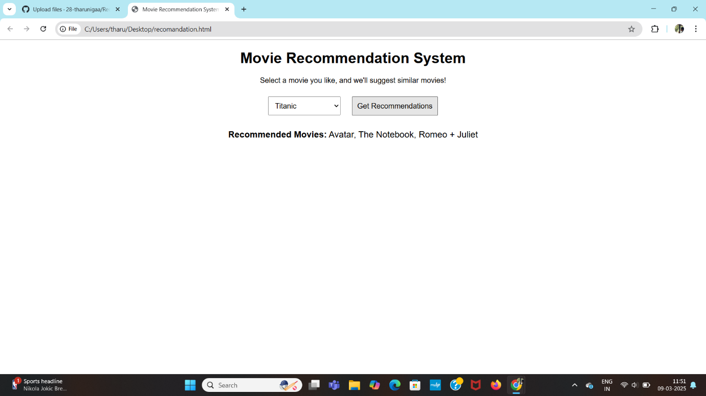

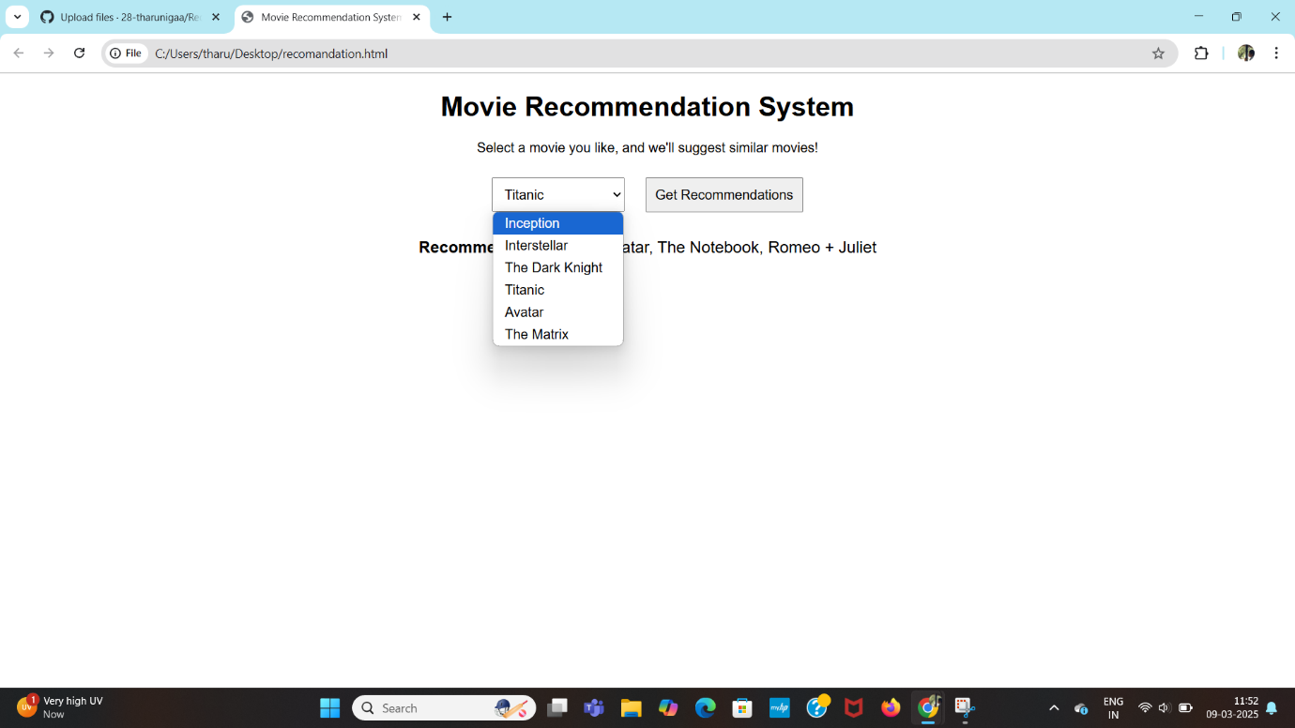

**Conclusion**

A recommendation system enhances user experience by providing personalized suggestions based on user preferences. By leveraging techniques like collaborative and content-based filtering, this system efficiently recommends relevant movies, books, or products. Future improvements can further optimize recommendations through deep learning and real-time data analysis.